Mastering Embedded Systems Online Diploma
www.learn-in-depth.com

First Term (Final Project 1)
Eng. mahmoud Elyamani

My Profile:
www.learn-in-depth-store.com/profile/mahmoud-elyamani-7/profile

System requirements:
- Pressure detection firmware.
- Alarm activation firmware when pressure exceeds 20 bar.
- Activation state stays on for 60 seconds before it turns off.
- The system is assumed to be on at all time.
- The controller’s turn on and turn off procedure are not taken into account.
- Pressure sensor and alarm are assumed to never fail.
- Controller’s maintenance is not taken into account.

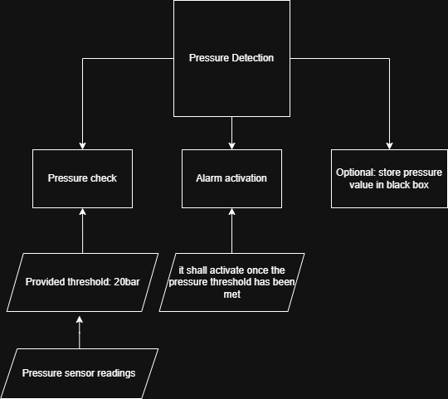

Use Case Diagram:
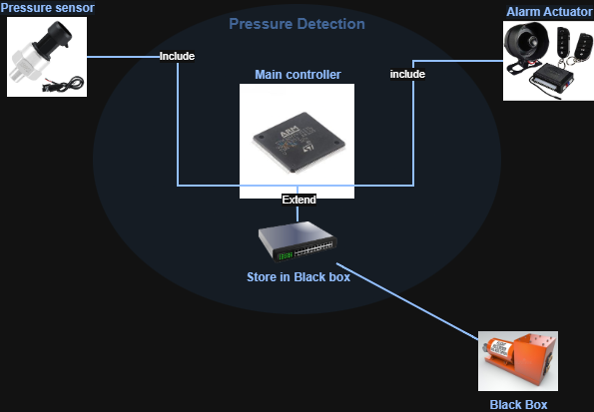

Sequence Diagram:

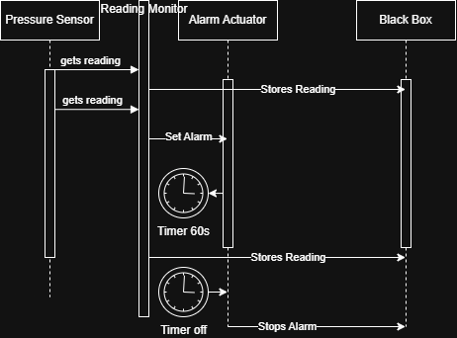

Activity Diagram:

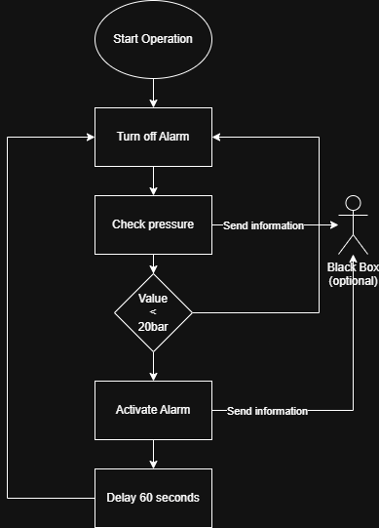

Main.c: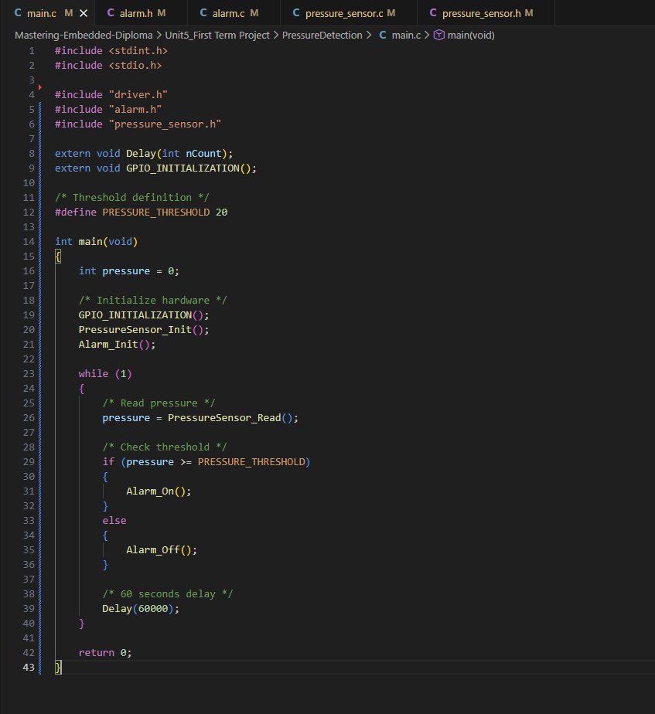

Pressure_Sensor.c:
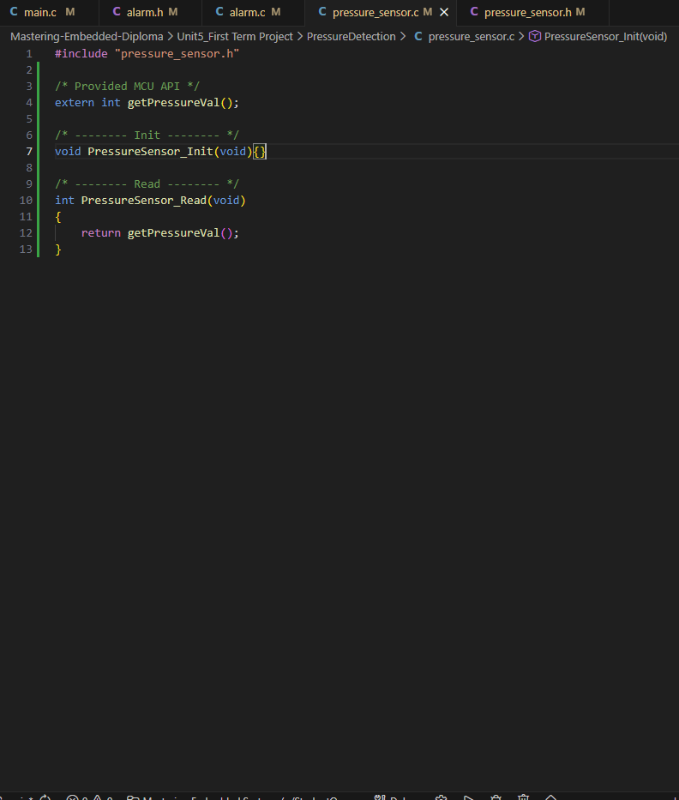

Pressure_Sensor.h:
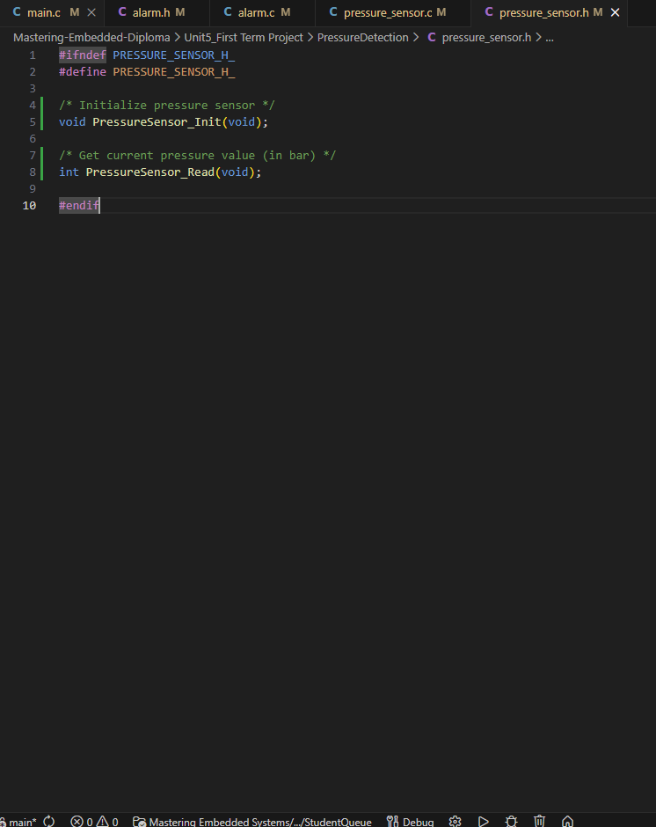

Alarm.c:
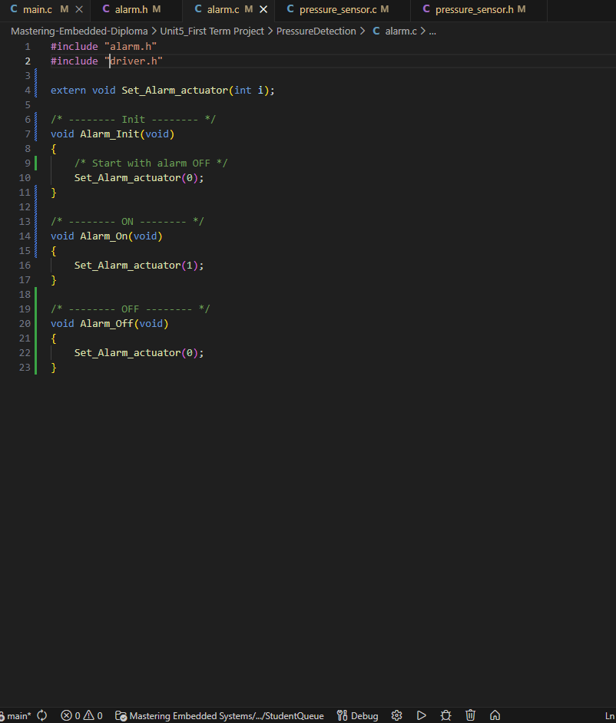

Alarm.h:

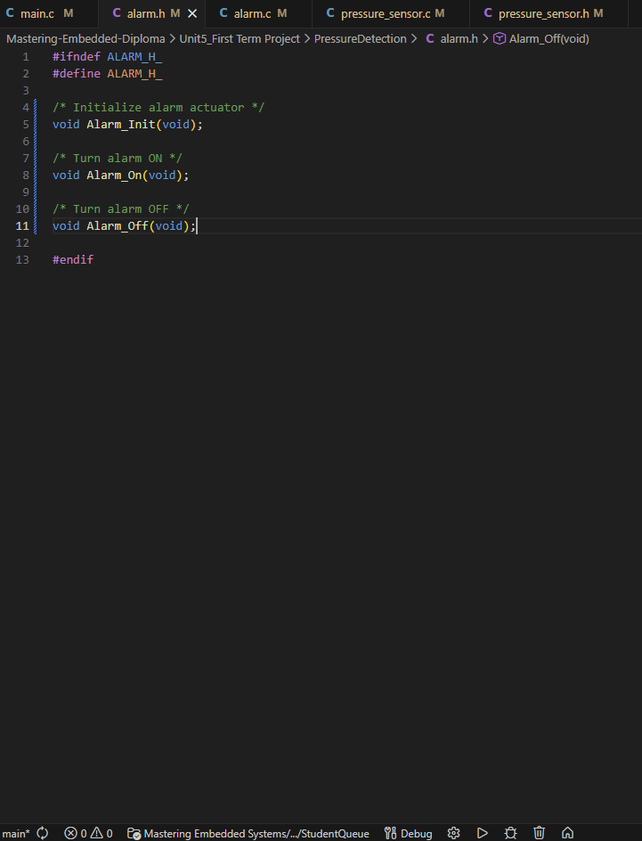

Alarm.o headers&symbols:

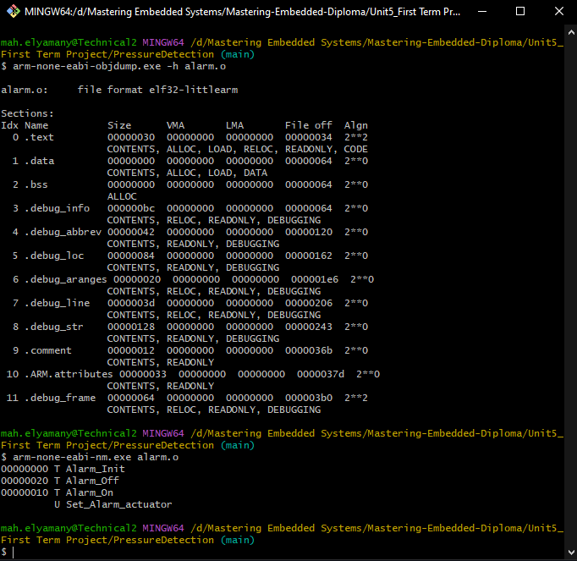

Pressure_Sensor.o headers&symbols:

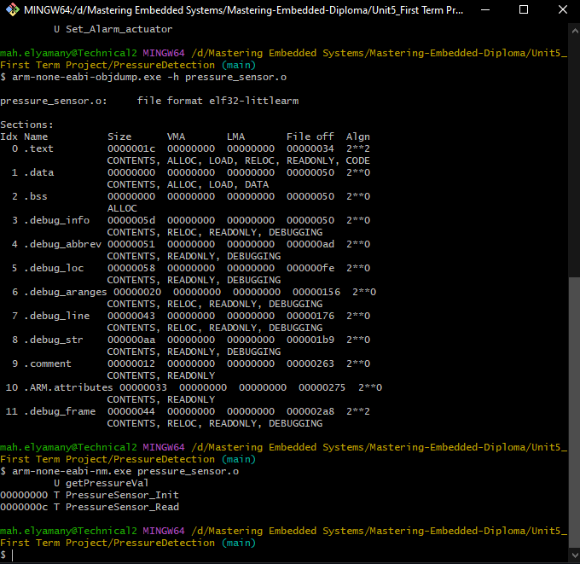

Main.o Headers&symbols:

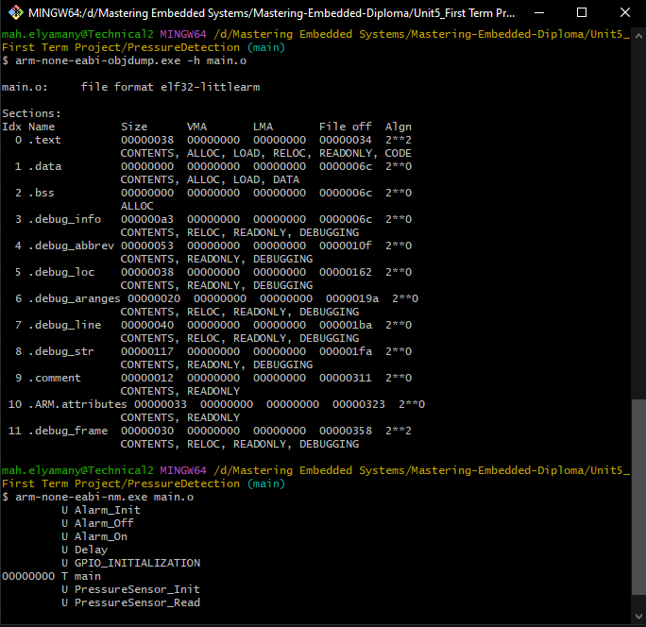

Mapfile:

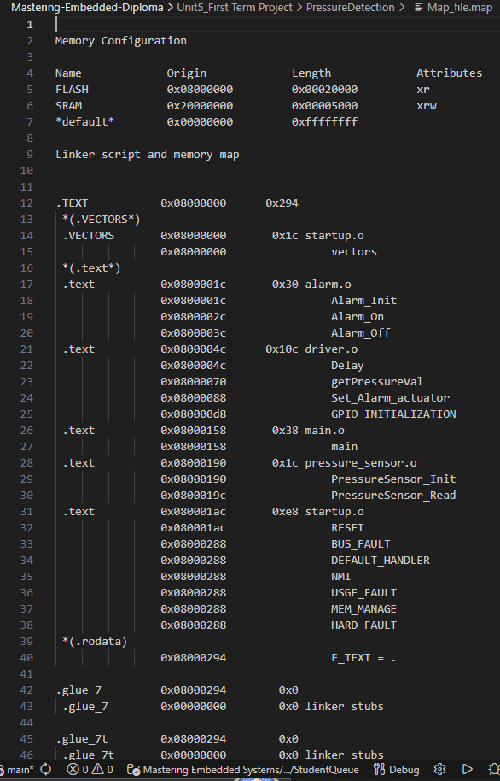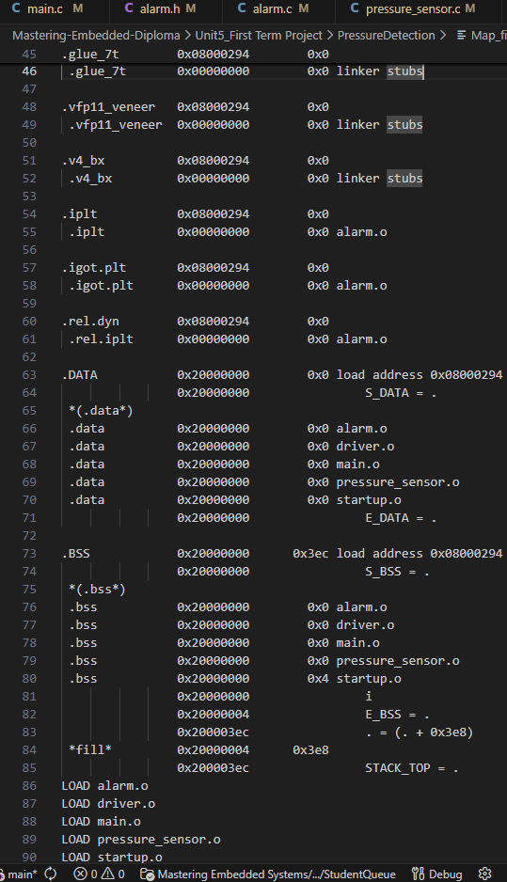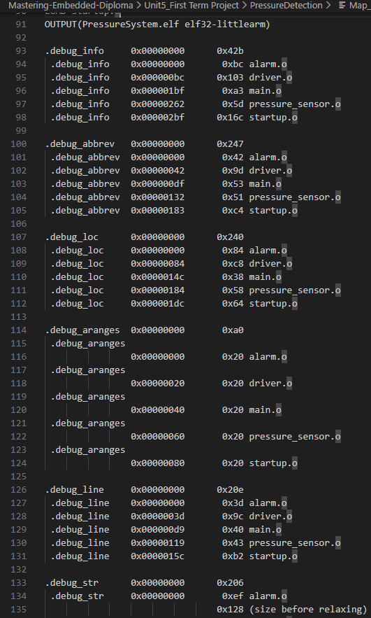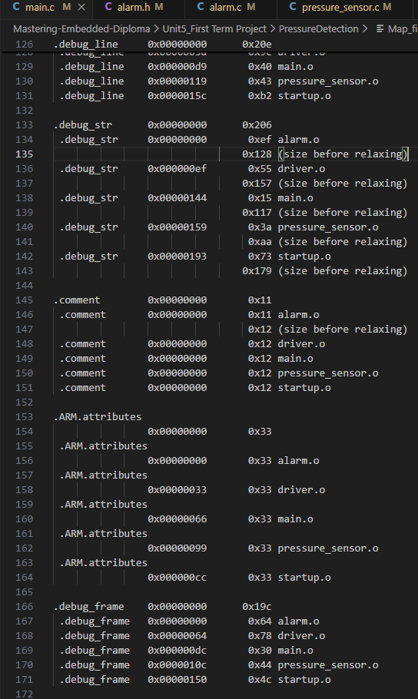

Simulation on Proteus:

